|  |  |  |
| --- | --- | --- |
|  | **TECHNICAL SPECIFICATIONS GUIDING WEBSITE** |  |

**A MINIPROJECT REPORT**

**Submitted by**

**Vaseharan. T (923820104058)**

**Manisairam. S (923820104028)**

**Nagasakthi kumar. S(923820104031)**

**Dinesh kumar. A.S (923820104302)**

**In Partial fulfillment for the award of the degree**

**Of**

**BACHELOR OF ENGINEERING**

**In**

**COMPUTER SCIENCE AND ENGINEERING**



**ANNA UNIVERSITY: CHENNAI 600 025**

**JUNE 2022**

**ACKNOWLEDGEMENT**

We express our gratefulness to our respectable Secretary Sir **Mr.P.Ashokkumar M.A., M.Ed.,BGL.** For having offered as the golden opportunity to do the project work in this prestigious institution.

We express our sincere thanks to our respected Managing Director Sir **Mr.A.Shakti Pranesh, B.E.MBA..,** For providing more facilities, to do this project work.

A deep bouquet of thanks to respected Principal Sir **Dr.J.Karthikeyan M.E.,Ph.D.**,**MBA, MIE,MISTE,C.Eng.** for having provided the facilities required for our project.

We sincerely thank Sir **Mr.A.Anna Arasu M.E.,** Assistant Professor and Head, Department of Computer Science and Engineering, Mangayarkarasi College of Engineering who inspired us and gave us time to make this project to work a grand success.

We also thank our guide **Mrs. Kezial Elizabeth M.E..**, Assistant Professor, Department of Computer Science and Engineering for his valuable guidance throughout and it is great privilege to express our gratitude to him.

We extend our heartfelt thanks and profound gratitude to all the faculty members of our department for their kind help during our project work.

Finally we express our sincere thanks to our parents, who have constantly encouraged us and for being the source of encouraging spirits throughout our course.

**ABSTRACT**

This project aims to develop a prebuilt PC and laptop suggestion website that assists users in selecting the most suitable preconfigured systems based on their specific needs and preferences. The website will provide a user-friendly interface where individuals can input their requirements, such budget, intended usage, desired specifications, and preferred brands. The suggestions will take into account factors like performance, price, reliability, customer reviews, and compatibility. Additionally, the website will offer detailed product information, comparisons, and user reviews to facilitate informed decision-making. By simplifying the process of choosing prebuilt PCs and laptops, this website aims to save users time and effort, ultimately enabling them to make well-informed purchases that align with their specific computing needs.

**INDEX**

|  |  |  |
| --- | --- | --- |
| **CHAPTER NO** | **CONTENTS** | **PAGENO** |
| **1.** | **INTRODUCTION** | **5** |
| **2.** | **SYNOPSIS** | **6** |
| **3.** | **SYSTEM REQUIREMENTS SPECIFICATION**  3.1. Objective  3.2. Purpose  3.3. Scope  3.4. Performance Requirement  3.5. Software Requirement  3.6. Hardware Requirement | 7  7  7  7  8  9  11  11 |
| **4.** | **SYSTEM ANALYSIS**  4.1. Existing System  4.2. Proposed System  4.3. DataFlow Diagram | 12  12  13  14 |
| **5.** | **SYSTEM DESIGN**  **5.1. System Architecture**  5.2. Modular Description | 16  17  18 |
| **6.** | **CODING** | 20 |
| **7.** | **TESTING**  7.1. Sample (Screenshost)  7.3. Project Specific Test Cases | 46  48 |
| **8.** | **SAMPLE OUTPUT** | 49 |
| **9.** | **BENEFITS** | 51 |
| **10.** | **LIMITATION** | 52 |
| **11.** | **FUTURE ENHANCEMENT** | 53 |
| **12.** | **REFERENCE** | 54 |

**1. INTRODUCTION**

Our website is designed to simplify the overwhelming process of building a PC by providing you with tailored recommendations based on your specific needs and preferences.

you're looking for a budget-friendly gaming rig or an experienced professional seeking a high-performance workstation, our intelligent recommendation system takes into account your usage requirements, desired performance levels, budget constraints, and even your aesthetic preferences. By analyzing these factors, we generate a personalized list of components that perfectly match your needs. Our website offers a user-friendly interface that guides you through the entire process. Simply answer a few questions about your intended usage, budget, and desired specifications.

Our website offers a user-friendly interface that guides you through the entire process. Simply answer a few questions about your intended usage, budget, and desired specifications.

**2. SYNOPSIS**

Our PC build recommendation system takes the guesswork out of selecting the right hardware for your specific needs.We strive to find the perfect balance between performance, affordability, and compatibility to ensure your PC build is optimized to meet your expectations.At PCBuild, we understand that every PC build is unique, tailored to individual preferences, requirements, and budgets. Our advanced recommendation system takes all of these factors into account, ensuring that you receive a custom-built solution that perfectly matches your needs.

you're a hardcore gamer seeking maximum performance, a creative professional demanding powerful hardware for your projects, or a budget-conscious user looking for the best value, our website will analyze your specific criteria to generate a comprehensive list of recommended components. But we don't stop at just providing a list of components. Our platform offers in-depth product reviews, detailed specifications, and real-world performance benchmarks, enabling you to make well-informed decisions.We believe that transparency and accuracy are crucial, so we source information from trusted experts and industry-leading manufacturers to ensure the highest quality recommendations.

We also understand that PC building is a dynamic process, with new technologies and components constantly hitting the market. That's why we stay up to date with the latest trends and advancements, regularly updating our database to ensure that our recommendations are based on the most cutting-edge hardware available . Whether you're a PC enthusiast, a creative professional, or a student in need of a reliable laptop, we're here to make your journey easier. Start exploring our recommendation system today and discover the ideal PC or laptop that empowers you to reach new heights!

**3. SYSTEM REQUIREMENTS SPECIFICATION**

**3.1. OBJECTIVE**

The objective of our PC build recommendation system is to simplify the process of selecting components for a custom PC build by providing personalized recommendations based on the user's specific needs, preferences, and budget.

**3.2. PURPOSE**

* Researching and comparing various components can be time-consuming and tedious. The purpose of our system is to save users valuable time and effort by automatically generating personalised build recommendations based on their requirements, eliminating the need for extensive research
* Building a PC requires careful consideration of component compatibility. Our system aims to eliminate compatibility issues by recommending components that work seamlessly together, ensuring a smooth and hassle-free assembly process.
* Not everyone has an unlimited budget for their PC builds. The purpose of our recommendation system is to offer cost-effective solutions that strike a balance between performance and affordability, allowing users to get the most value out of their investments.
* Recognizing that not all users require a desktop PC, the purpose of our system is to cater to a wide range of needs by providing recommendations for both PC builds and laptops. Whether users prefer the flexibility of a laptop for on-the-go productivity or the power and expandability of a desktop PC, our system offers tailored recommendations to meet their preferences.
* Our system understands that laptops can serve multiple purposes, ranging from gaming to graphic design to business applications. The purpose is to recommend versatile laptops that can handle various tasks, ensuring users have the flexibility to pursue their interests and professional endeavors without compromise.

**3.3 SCOPE**

The scope for a PC build and laptop recommendation website is

* A significant aspect of the website's scope is to provide recommendations that fit within users' budget constraints.
* The main scope of the website is to produce recommendations according to the user's profession.
* The scope includes staying up to date with the latest advancements in PC hardware and laptops.
* The website should regularly update its database of components, models, and technologies to provide users with the most current recommendations.

**METHOD**

Conducting surveys to collect information directly from users regarding their needs, preferences, and budget constraints. Surveys can include questions about intended usage, desired performance levels, aesthetic preferences, software requirements, and more.

Conducting market research helps in understanding the latest trends, technologies, and product offerings in the PC hardware and laptop market. This method involves studying market reports, industry publications, and monitoring new product releases to stay informed about the latest advancements.

Creating prototype PC builds or using prototype laptops to gather user feedback and evaluate performance can be an effective method. This involves building and testing different configurations to assess their performance, usability, and compatibility with various software and applications.

**3.4. PERFORMANCE REQUIREMENT**

**Responsiveness**:

The website should load quickly and respond promptly to user actions. Aim for fast page load times and minimize any lag or delay in displaying product information.

**Scalability:**

The website should be able to handle a significant number of concurrent users without performance degradation. As your website grows in popularity, it should be able to scale its infrastructure to meet increased traffic demands.

**Product Listing and Details:**

Displaying product listings and detailed specifications should be efficient and optimized. The website should handle large amounts of product data and present it in an organized and visually appealing manner.

**Images and Media:**

Loading product images and media files should be quick and optimized to prevent slowdowns. Consider compressing images without compromising quality to reduce loading times.

**Mobile Responsiveness:**

Ensure that the website is responsive and optimized for mobile devices. Mobile users should have a seamless experience, with easy navigation and fast loading times on smartphones and tablets.

**Regular Updates and Maintenance:**

Perform regular updates and maintenance to keep the website optimized and secure. This includes updating software components, patching security vulnerabilities, and addressing any performance issues.

**Analytics and Monitoring:**

Implement analytics tools to track website performance, user behavior, and conversion rates. Use monitoring systems to identify and resolve any performance bottlenecks or issues promptly.

**Error Handling:**

Implement proper error handling mechanisms to handle exceptions and errors gracefully. Display user-friendly error messages and provide a fallback mechanism in case of failures to prevent a negative user experience.

**Load Testing:**

Conduct load testing to simulate high traffic conditions and ensure that the website can handle the expected load without significant performance degradation. Identify and resolve any bottlenecks or scalability issues that arise during load testing. **Mobile-Friendly Design:**

Ensure that the website is designed with a mobile-first approach, providing an optimal user experience on various screen sizes and devices. Implement responsive design techniques to adapt the layout and content to different screen resolutions.

**Lazy Loading:**

Implement lazy loading techniques for images and other non-critical resources. This means loading content as the user scrolls, rather than all at once, to reduce initial page load times and improve perceived performance

**Browser Compatibility:**

Ensure that the website is compatible with popular web browsers, such as Chrome, Firefox, Safari, and Edge. Test the website thoroughly on different browsers and versions to ensure consistent performance and functionality.

**3.5. SOFTWARE REQUIREMENT**

The Below Software Specifications were used to develop the Pc Build recommendation website

Operating System : Windows 11

Technology Used : HTML,Javascript,CSS,

**3.6. HARDWARE REQUIREMENT**

The Below Hardware Specifications were used to develop the PC Build suggestion System

Processor : AMD 5 5600H

Processor Speed : 4.2 GHz

RAM : 8 GB

Hard Disk Drive : 500 GB

Monitor : “15” inches

**4. SYSTEM ANALYSIS**

**4.1. EXISTING SYSTEM**

* The existing suggested website does not depend on a user's profession.
* Our website suggests a PC or laptop according to the user's profession.
* PC build suggestions are based on product sales motivation.
* PC build suggestions are based on product sales motivation, but our website doesn't link to the e-commerce site, so the user can only take a suggestion from us.
* There is no bench mark for each component in the PC.

**Disadvantages:**

* Users with specific area requirements, such as specialized software needs, overclocking capabilities, or compatibility with specific peripherals, may find that the recommendations from these websites do not fully address their specific requirement.
* The recommendations provided by these websites are based on the current market offerings and technologies. They may not consider upcoming or future releases, meaning users might miss out on potentially better options that become available shortly after their recommendation.
* Some recommendation websites may have partnerships or affiliate relationships with specific brands or retailers.

**4.2. PROPOSED SYSTEM**

Our websites produce laptop suggestions. Regularly update the database with the latest components, laptops, and pricing information to ensure accuracy and relevancy.

Monitor user feedback, address issues or bugs, and incorporate user suggestions to improve the system over time. Create an intuitive and user-friendly interface that guides users through the recommendation process, making it easy to navigate, input preferences, and view results.

**Advantages:**

* These websites help users save time and effort by providing a streamlined process for selecting PC components or laptops. Instead of researching and comparing numerous options individually, users can rely on the website's recommendations to quickly identify suitable choices.
* Many recommendation websites leverage the expertise and knowledge of PC hardware enthusiasts, industry experts, or technology professionals. The recommendations are often based on extensive research, benchmarking, and testing, providing users with insights and expertise they may not possess themselves.
* These websites typically include compatibility checks, ensuring that recommended components are compatible with each other and the user's requirements.

**4.3. DATA FLOW DIAGRAM**

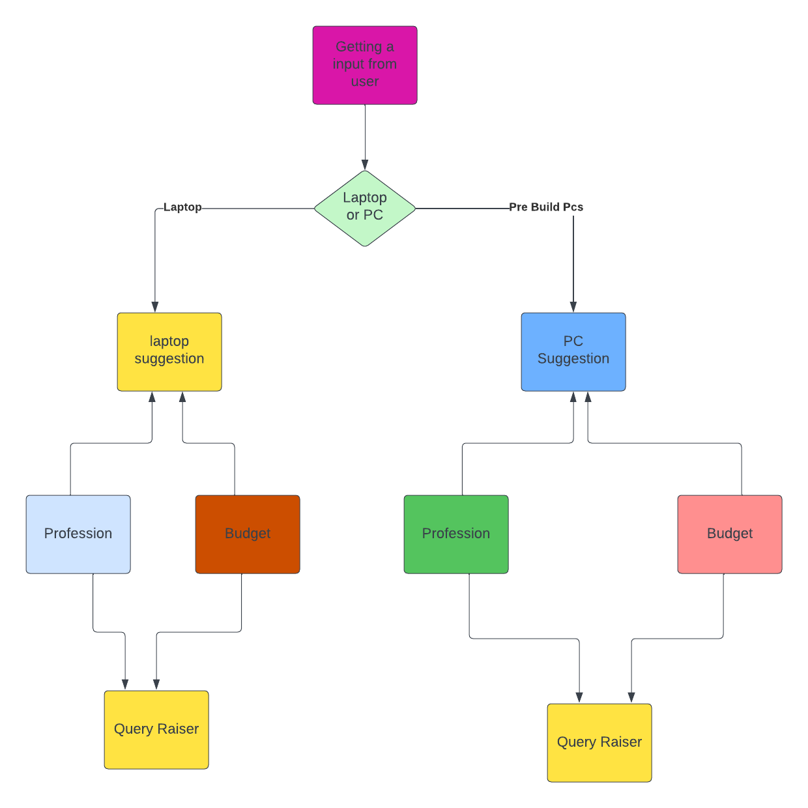

**DFD Explanation:**

In the above data flow diagram, the user data flow is described, and then the data flows into the five components to suggest a PC or laptop to the customer. they are laptop suggestion page and PC suggestion page, and then both suggestions are made with the help of the profession and budget components.

The Steps are as follows –

1. First, the user selects the suggestion they want.
2. If the customer selects the PC, then the pre-built PCs are displayed to the customer; otherwise, the customer chooses the laptop suggestion page.
3. Both suggestions are made with the help of the user's profession and budget.
4. Benchmarks of the suggested components are displayed.

**5. SYSTEM DESIGN**

**5.1. SYSTEM ARCHITECTURE**

Query raiser

Benchmark of Suggested product

Prebuild PCs and laptop are suggested

Suggestion based on a User Budget

Suggestion based on a User profession

Laptop or PC

**System Design Explanation:**

**Laptop page:**

The Laptop Suggestion Page module is responsible for offering users a seamless experience in finding the most suitable laptops based on their needs. It leverages the Recommendation Engine module, which analyzes user preferences and requirements to generate personalized recommendations. The module interacts with the User Authentication module to ensure that only authenticated users can access and receive laptop suggestions.

**PC Suggestion:**

The Pre-Built PC Suggestion Page module displays the recommended pre-built PCs through an intuitive user interface. Each recommendation includes detailed information about the PC's specifications, pricing, user ratings, and links for additional details. The interface may also provide options for users to compare multiple pre-built PCs side by side, save preferred choices, or proceed with the purchase.

**Query Raiser:**

The Query Raiser module plays a vital role in improving the search and recommendation capabilities of the pre-built PC build and laptop suggestion website. Its primary function is to collect and process user queries to enhance the overall user experience.When users input their queries through the website's user interface, the Query Raiser module captures the search terms and filters used by the user to refine their search. It analyzes the query to identify the user's intent and translates it into specific parameters that can be used to search and retrieve relevant pre-built PCs and laptops from the Product Database.

**5.2.. MODULAR DESCRIPTION**

First, the user selects what type of product they want and if it is a laptop or PC, and then the suggestions are filtered based on the user's profession and budget, and the user can see their product benchmark. If the product is a laptop, there will be an overall performance score on the website. If it is a PC, the user can see each component's performance.

1. **Laptop:**

In the laptop module, all the laptops are categorised by the user's profession and budget. and then the laptop benchmark score is displayed on the website. Heat generation issues are also displayed. The power consumption and battery performance of the laptop were also displayed.

Gaming benchmarks are also displayed for the gamers.

1. **Desktop:**

In the desktop module,  all the prebuilt PCs are suggested. The suggestion is based on the user profession and the budget, and each profession is alerted for some components. The detailed benchmarks of the components are displayed on the website and this module contains a larger number of products, which are efficiently categorised by us. The products are described in a very user-friendly manner, and then the user can explore the products very well.

1. **Query raiser:**

The query raiser module is placed in all products and is used to communicate with the user with us. If the customer has any doubts about the suggestion, they may raise a query with us, and we can answer the question very quickly.

1. **Product Analysis:**

In the product analysis phase, there are various products listed on the website that are handled in the right way based on the user's profession and budget. All the products benchmarked are categorised and checked to see if they are worth the cost and whether they perform very well or not.

1. **User about the product:**

In this phase, how the user is searching for the product and then how they look at and dive into the product are analysed very well and optimised according to the user's search.

**6.CODING**

## Home .html:

<section data-bs-version="5.1" class="menu" group="Menu" plugins="DropDown, TouchSwipe" always-top global once="menu" not-draggable position-absolute>

<mbr-parameters>

<header>Size</header>

<input type="checkbox" name="fullWidth" title="Full Width">

<header>Show/Hide</header>

<input type="checkbox" title="Logo" name="showLogo" checked>

<input type="range" title="Logo Size" inline name="logoSize" min="3.8" max="8" step="0.1" value="3.8" condition="showLogo">

<input type="checkbox" title="Brand Name" name="showBrand" checked>

<input type="checkbox" title="Menu Items" name="showItems" checked>

<input type="checkbox" title="Icons" name="showIcons" checked>

<select title="Amount" name="iconsAmount" condition="showIcons">

<option value="1">1</option>

<option value="2">2</option>

<option value="3" selected>3</option>

<option value="4">4</option>

</select>

<input type="color" title="Icons Color" name="iconsColor" value="#9fdbf8" condition="showIcons">

<input type="checkbox" title="Button" name="showButtons">

<header>Styles</header>

<input type="checkbox" title="Sticky" name="sticky" checked>

<input type="checkbox" title="Collapsed" name="collapsed">

<input type="checkbox" title="Transparent" name="transparent">

<input type="range" title="Opacity" name="opacity" min="0" max="1" step="0.1" value="0.2" condition="transparent">

<input type="color" title="Color" name="menuBgColor" value="#232323">

</mbr-parameters>

<nav class="navbar navbar-dropdown" mbr-class="{'navbar-fixed-top':sticky,

'navbar-expand-lg':!collapsed,

'collapsed':collapsed}">

<div mbr-class="{'container': !fullWidth, 'container-fluid': fullWidth}">

<div class="navbar-brand">

<span mbr-if="showLogo" class="navbar-logo">

<a href="https://mobiri.se">

<img src="file:///C:/Users/Vasekarthi/AppData/Local/Mobirise.com/Mobirise/projects/project-2023-02-26_182853/assets/images/0x0-144x126.jpg" alt="Mobirise Website Builder" mbr-style="{'height': logoSize + 'rem'}">

</a>

</span>

<span mbr-if="showBrand" mbr-buttons mbr-theme-style="display-7" class="navbar-caption-wrap" data-toolbar="-mbrBtnMove,-mbrBtnAdd,-mbrBtnRemove"><a class="navbar-caption text-white" data-app-selector=".navbar-caption" href="https://mobiri.se" data-app-placeholder="Type Text"><span class="mobi-mbri mobi-mbri-to-ftp mbr-iconfont mbr-iconfont-btn"></span>PCBUILDER</a></span>

</div>

<button class="navbar-toggler" type="button" data-toggle="collapse" data-bs-toggle="collapse" data-target="#navbarSupportedContent" data-bs-target="#navbarSupportedContent" aria-controls="navbarNavAltMarkup" aria-expanded="false" aria-label="Toggle navigation" mbr-if="showItems">

<div class="hamburger">

<span></span>

<span></span>

<span></span>

<span></span>

</div>

</button>

<div class="collapse navbar-collapse" id="navbarSupportedContent">

<ul mbr-menu class="navbar-nav nav-dropdown" mbr-theme-style="display-4" mbr-class="{'nav-right': !showButtons,'navbar-nav-top-padding': isPublish && !showBrand && !showLogo}"><li class="nav-item"><a class="nav-link link text-white text-primary" href="page2.html" data-app-selector=".nav-link,.dropdown-item" data-app-placeholder="Type Text" target="_blank">LAPTOP</a></li>

<li class="nav-item"><a class="nav-link link text-white text-primary" href="page1.html" data-app-selector=".nav-link,.dropdown-item" data-app-placeholder="Type Text" target="_blank">DESKTOP</a></li></ul>

<div class="icons-menu" mbr-if="showIcons">

<a class="iconfont-wrapper" href="https://mobiri.se" target="_blank">

<span mbr-icon class="p-2 mbr-iconfont socicon-facebook socicon"></span>

</a>

<a class="iconfont-wrapper" href="https://mobiri.se" target="_blank" mbr-if="iconsAmount > 1">

<span mbr-icon class="p-2 mbr-iconfont socicon-twitter socicon"></span>

</a>

<a class="iconfont-wrapper" href="https://mobiri.se" target="_blank" mbr-if="iconsAmount > 2">

<span mbr-icon class="p-2 mbr-iconfont socicon-instagram socicon"></span>

</a>

<a class="iconfont-wrapper" href="https://mobiri.se" target="_blank" mbr-if="iconsAmount > 3">

<span mbr-icon class="p-2 mbr-iconfont socicon-linkedin socicon"></span>

</a>

</div>

<div mbr-if="showButtons" mbr-buttons mbr-theme-style="display-4" class="navbar-buttons mbr-section-btn"><a class="btn btn-primary" href="https://mobiri.se" data-app-placeholder="Type Text"> Download Now</a></div>

</div>

</div>

</nav>

</section>

<section data-bs-version="5.1" class="header1" group="Headers" data-bg-video="{{bg.type == 'video' && bg.value.url}}" mbr-class="{

'mbr-fullscreen': fullScreen,

'mbr-parallax-background': bg.parallax}">

<mbr-parameters>

<header>Size</header>

<input type="checkbox" title="Full Screen" name="fullScreen" checked>

<input type="checkbox" title="Full Width" name="fullWidth">

<input type="range" inline title="Top" name="paddingTop" min="0" max="10" step="1" value="5" condition="fullScreen == false">

<input type="range" inline title="Bottom" name="paddingBottom" min="0" max="10" step="1" value="5" condition="fullScreen == false">

<input type="range" inline name="textWidth" title="Width" min="4" max="12" value="8" step="1">

<select title="Align" name="contentAlign">

<option value>Left</option>

<option value="justify-content-center" selected>Center</option>

<option value="justify-content-end">Right</option>

</select>

<header>Show/Hide</header>

<input type="checkbox" title="Title" name="showTitle" checked>

<input type="checkbox" title="Subtitle" name="showSubitle">

<input type="checkbox" title="Text" name="showText" checked>

<input type="checkbox" title="Buttons" name="showButtons" checked>

<header>Background</header>

<fieldset type="background" name="bg" parallax>

<input type="image" title="Image" value="file:///C:/Users/Vasekarthi/AppData/Local/Mobirise.com/Mobirise/projects/project-2023-02-26_182853/assets/images/wallpaperflare.com_wallpaper%20(2)-2000x1500.jpg" selected parallax>

<input type="color" title="Color" value="#ffffff">

<input type="video" title="Video" value="https://vimeo.com/428046504">

</fieldset>

<input type="checkbox" title="Overlay" name="overlay" condition="bg.type !== 'color'" checked>

<input type="color" title="Overlay Color" name="overlayColor" value="#000000" condition="overlay && bg.type !== 'color'">

<input type="range" inline title="Opacity" name="overlayOpacity" min="0" max="1" step="0.1" value="0.3" condition="overlay && bg.type !== 'color'">

</mbr-parameters>

<div class="mbr-overlay" mbr-if="overlay && bg.type !== 'color'" opacity="{{overlayOpacity}}" bg-color="{{overlayColor}}"></div>

<div class="align-center" mbr-class="{'container': !fullWidth, 'container-fluid': fullWidth}">

<div class="row {{contentAlign}}">

<div class="col-12 col-lg-{{textWidth}}">

<h1 class="mbr-section-title mbr-fonts-style mb-3" data-app-selector=".mbr-section-title" mbr-theme-style="display-1" mbr-if="showTitle"><b>BUILD YOUR OWN PC</b></h1>

<h2 class="mbr-section-title mbr-fonts-style mb-3" data-app-selector=".mbr-section-title" mbr-theme-style="display-2" mbr-if="showSubitle">Header Subtitle</h2>

<p class="mbr-text mbr-fonts-style" mbr-theme-style="display-7" mbr-if="showText" data-app-selector=".mbr-text, .mbr-section-btn">A&nbsp;custom-built or&nbsp;homebuilt computer is one assembled from available components, usually commercial off-the-shelf&nbsp;(COTS) components, rather than purchased as a complete system from a computer system supplier, also known as pre-built systems.

<br><br></p>

<div mbr-buttons mbr-theme-style="display-4" class="mbr-section-btn mt-3" mbr-if="showButtons"><a class="btn btn-black" href="page1.html#gallery2-o" data-app-placeholder="Type Text" target="_blank">DESKTOP</a> <a class="btn btn-black" href="page2.html#contacts4-u" data-app-placeholder="Type Text" target="_blank">LAPTOP&nbsp;</a> <a class="btn btn-black" href="https://mobiri.se" data-app-placeholder="Type Text">CUSTOM&nbsp;</a></div>

</div>

</div>

</div>

</section>

<section data-bs-version="5.1" class="content1" group="Content" data-bg-video="{{bg.type == 'video'&&bg.value.url}}" mbr-class="{

'mbr-fullscreen': fullScreen,

'mbr-parallax-background': bg.parallax}">

<mbr-parameters>

<header>Size</header>

<input type="checkbox" title="Full Screen" name="fullScreen">

<input type="checkbox" title="Full Width" name="fullWidth">

<input type="range" inline title="Top" name="paddingTop" min="0" max="10" step="1" value="2" condition="fullScreen == false">

<input type="range" inline title="Bottom" name="paddingBottom" min="0" max="10" step="1" value="2" condition="fullScreen == false">

<input type="range" name="textWidth" title="Width" min="4" max="12" step="1" value="9">

<header>Show/Hide</header>

<input type="checkbox" title="Title" name="showTitle" checked>

<input type="checkbox" title="Subtitle" name="showSubtitle" checked>

<input type="checkbox" title="Buttons" name="showButtons">

<header>Background</header>

<fieldset type="background" name="bg" parallax>

<input type="image" title="Image" value="file:///C:/Users/Vasekarthi/AppData/Local/Mobirise.com/Mobirise/projects/project-2023-02-26_182853/assets/images/background1-1.jpg">

<input type="color" title="Color" value="#232323" selected>

<input type="video" title="Video" value="https://vimeo.com/428046504">

</fieldset>

<input type="checkbox" title="Overlay" name="overlay" condition="bg.type !== 'color'" checked>

<input type="color" title="Overlay Color" name="overlayColor" value="#ffffff" condition="overlay && bg.type !== 'color'">

<input type="range" inline title="Opacity" name="overlayOpacity" min="0" max="1" step="0.1" value="0.8" condition="overlay && bg.type !== 'color'">

</mbr-parameters>

<div mbr-class="{'container': !fullWidth, 'container-fluid': fullWidth}">

<div class="row justify-content-center">

<div class="title col-12 col-md-{{textWidth}}">

<h3 class="mbr-section-title mbr-fonts-style align-center mb-4" mbr-if="showTitle" data-app-selector=".mbr-section-title" mbr-theme-style="display-2"><b>PC HARDWARE</b></h3>

<h4 class="mbr-section-subtitle align-center mbr-fonts-style mb-4" mbr-if="showSubtitle" data-app-selector=".mbr-section-subtitle" mbr-theme-style="display-7">Want to know what hardware is in your computer? Become a computer pro with our quick guide to these essential components and their roles.

<div>

</div><div>Quite simply, computer hardware is the physical components that a computer system requires to function. It encompasses everything with a circuit board that operates within a PC or laptop; including the motherboard, graphics card, CPU (Central Processing Unit), ventilation fans, webcam, power supply, and so on.</div></h4>

<div class="mbr-section-btn align-center" mbr-if="showButtons" mbr-buttons mbr-theme-style="display-4">

<a class="btn btn-primary" href="https://mobiri.se">LEARN MORE</a>

<a class="btn btn-primary-outline" href="https://mobiri.se">LIVE DEMO</a>

</div>

</div>

</div>

</div>

</section>

<section data-bs-version="5.1" class="image3" group="Images" data-bg-video="{{bg.type == 'video' && bg.value.url}}" mbr-class="{'mbr-fullscreen': fullScreen,

'mbr-parallax-background': bg.parallax}">

<mbr-parameters>

<header>Size</header>

<input type="checkbox" title="Full Screen" name="fullScreen">

<input type="checkbox" title="Full Width" name="fullWidth">

<input type="range" inline title="Top" name="paddingTop" min="0" max="10" step="1" value="2" condition="fullScreen == false">

<input type="range" inline title="Bottom" name="paddingBottom" min="0" max="10" step="1" value="2" condition="fullScreen == false">

<input type="range" name="textWidth" title="Image" min="4" max="12" step="1" value="9">

<header>Show/Hide</header>

<input type="checkbox" title="Text" name="showText" checked>

<header>Background</header>

<fieldset type="background" name="bg" parallax>

<input type="image" title="Image" value="../_images/background1.jpg">

<input type="color" title="Color" value="#000000" selected>

<input type="video" title="Video" value="https://vimeo.com/428046504">

</fieldset>

<input type="checkbox" title="Overlay" name="overlay" condition="bg.type !== 'color'" checked>

<input type="color" title="Overlay Color" name="overlayColor" value="#ffffff" condition="overlay && bg.type !== 'color'">

<input type="range" inline title="Opacity" name="overlayOpacity" min="0" max="1" step="0.1" value="0.7" condition="overlay && bg.type !== 'color'">

</mbr-parameters>

<div class="mbr-overlay" mbr-if="overlay && bg.type!== 'color'" mbr-style="{'opacity': overlayOpacity, 'background-color': overlayColor}">

</div>

<div mbr-class="{'container': !fullWidth, 'container-fluid': fullWidth}">

<div class="row justify-content-center">

<div class="col-12 col-lg-{{textWidth}}">

<div class="image-wrapper">

<img src="file:///C:/Users/Vasekarthi/AppData/Local/Mobirise.com/Mobirise/projects/project-2023-02-26_182853/assets/images/wallpaperflare.com_wallpaper-1916x1078.jpg" alt="Mobirise Website Builder">

<p class="mbr-description mbr-fonts-style mt-2 align-center" mbr-theme-style="display-4" mbr-if="showText" data-app-selector=".mbr-description">

Image Description</p>

</div>

</div>

</div>

</div>

</section>

<section data-bs-version="5.1" class="content1" group="Content" data-bg-video="{{bg.type == 'video'&&bg.value.url}}" mbr-class="{

'mbr-fullscreen': fullScreen,

'mbr-parallax-background': bg.parallax}">

<mbr-parameters>

<header>Size</header>

<input type="checkbox" title="Full Screen" name="fullScreen">

<input type="checkbox" title="Full Width" name="fullWidth">

<input type="range" inline title="Top" name="paddingTop" min="0" max="10" step="1" value="2" condition="fullScreen == false">

<input type="range" inline title="Bottom" name="paddingBottom" min="0" max="10" step="1" value="2" condition="fullScreen == false">

<input type="range" name="textWidth" title="Width" min="4" max="12" step="1" value="9">

<header>Show/Hide</header>

<input type="checkbox" title="Title" name="showTitle" checked>

<input type="checkbox" title="Subtitle" name="showSubtitle" checked>

<input type="checkbox" title="Buttons" name="showButtons">

<header>Background</header>

<fieldset type="background" name="bg" parallax>

<input type="image" title="Image" value="file:///C:/Users/Vasekarthi/AppData/Local/Mobirise.com/Mobirise/projects/project-2023-02-26_182853/assets/images/background1-1.jpg">

<input type="color" title="Color" value="#232323" selected>

<input type="video" title="Video" value="https://vimeo.com/428046504">

</fieldset>

<input type="checkbox" title="Overlay" name="overlay" condition="bg.type !== 'color'" checked>

<input type="color" title="Overlay Color" name="overlayColor" value="#ffffff" condition="overlay && bg.type !== 'color'">

<input type="range" inline title="Opacity" name="overlayOpacity" min="0" max="1" step="0.1" value="0.8" condition="overlay && bg.type !== 'color'">

</mbr-parameters>

<div mbr-class="{'container': !fullWidth, 'container-fluid': fullWidth}">

<div class="row justify-content-center">

<div class="title col-12 col-md-{{textWidth}}">

<h3 class="mbr-section-title mbr-fonts-style align-center mb-4" mbr-if="showTitle" data-app-selector=".mbr-section-title" mbr-theme-style="display-2"><b>LAPTOP</b></h3>

<h4 class="mbr-section-subtitle align-center mbr-fonts-style mb-4" mbr-if="showSubtitle" data-app-selector=".mbr-section-subtitle" mbr-theme-style="display-7">A laptop, sometimes called a notebook computer by manufacturers, is a battery- or AC-powered personal computer (PC) smaller than a briefcase. A laptop can be easily transported and used in temporary spaces such as on airplanes, in libraries, temporary offices and at meetings.

<div>

</div><div>A laptop can be turned into a desktop computer with a docking station, which is a hardware frame that supplies connections for peripheral input/output devices such as a monitor, keyboard and printer.</div></h4>

<div class="mbr-section-btn align-center" mbr-if="showButtons" mbr-buttons mbr-theme-style="display-4">

<a class="btn btn-primary" href="https://mobiri.se">LEARN MORE</a>

<a class="btn btn-primary-outline" href="https://mobiri.se">LIVE DEMO</a>

</div>

</div>

</div>

</div>

</section>

## Home.CSS:

@fullWidth: false;

@showLogo: true;

@logoSize: 3.8;

@showBrand: true;

@showItems: true;

@showIcons: true;

@iconsAmount: "3";

@iconsColor: #9fdbf8;

@showButtons: false;

@sticky: true;

@collapsed: false;

@transparent: false;

@opacity: 0.2;

@menuBgColor: #232323;

& when not (@sticky) {

.navbar-dropdown {

position: relative !important;

}

}

& when (@sticky) {

z-index: 1000;

width: 100%;

& when not (@transparent) {

position: relative;

min-height: 60px;

}

nav.navbar {

position: fixed;

}

}

.dropdown-item:before {

font-family: Moririse2 !important;

content: '\e966';

display: inline-block;

width: 0;

position: absolute;

left: 1rem;

top: 0.5rem;

margin-right: 0.5rem;

line-height: 1;

font-size: inherit;

vertical-align: middle;

text-align: center;

overflow: hidden;

transform: scale(0, 1);

transition: all 0.25s ease-in-out;

}

.dropdown-menu {

padding: 0;

}

.dropdown-item {

border-bottom: 1px solid #e6e6e6;

&:hover, &:focus {

background: @primaryColor !important;

color: white !important;

}

}

.nav-dropdown .link {

padding: 0 0.3em !important;

margin: .667em 1em !important;

}

.nav-dropdown .link.dropdown-toggle::after {

margin-left: 0.5rem;

margin-top: 0.2rem;

}

.nav-link {

position: relative;

}

.container {

display: flex;

margin: auto;

}

.iconfont-wrapper {

color: @iconsColor !important;

font-size: 1.5rem;

padding-right: .5rem;

}

.navbar-caption {

padding-right: 4rem;

}

.navbar-nav {

}

.dropdown-menu, .navbar.opened {

background: @menuBgColor !important;

}

.nav-item:focus, .nav-link:focus {

outline: none;

}

.dropdown .dropdown-menu .dropdown-item {

width: auto;

transition: all 0.25s ease-in-out;

&::after {

right: 0.5rem;

}

.mbr-iconfont {

margin-left: -1.8rem;

padding-right: 1rem;

font-size: inherit;

&:before {

display: inline-block;

transform: scale(1, 1);

transition: all 0.25s ease-in-out;

}

}

}

.collapsed {

.dropdown-menu .dropdown-item:before {

display: none;

}

.dropdown .dropdown-menu .dropdown-item {

padding: 0.235em 1.5em 0.235em 1.5em !important;

transition: none;

margin: 0 !important;

}

}

.navbar {

min-height: 77px;

transition: all .3s;

border-bottom: 1px solid transparent;

&:not(.navbar-short) {

border-bottom: 1px solid #e6e6e6;

}

& when not (@transparent) {

background: @menuBgColor;

}

& when (@transparent) {

background: rgba(red(@menuBgColor), green(@menuBgColor), blue(@menuBgColor), @opacity);

}

&.opened {

transition: all .3s;

}

.dropdown-item {

padding: .5rem 1.8rem;

}

.navbar-logo img {

width: auto;

}

.navbar-collapse {

justify-content: flex-end;

z-index: 1;

& when not (@showItems) {

display: none !important;

}

}

&.collapsed {

.nav-item .nav-link::before {

display: none;

}

&.opened {

.dropdown-menu {

top: 0;

}

@media (min-width: 992px) {

&:not(.navbar-short) .navbar-collapse when (@showLogo) {

max-height: ~"calc(98.5vh - @{logoSize}rem)";

}

}

}

.dropdown-menu {

.dropdown-submenu {

left: 0 !important;

}

.dropdown-item:after {

right: auto;

}

.dropdown-toggle[data-toggle="dropdown-submenu"]:after {

margin-left: 0.5rem;

margin-top: 0.2rem;

border-top: 0.35em solid;

border-right: 0.35em solid transparent;

border-left: 0.35em solid transparent;

border-bottom: 0;

top: 55%;

}

}

ul.navbar-nav {

li {

margin: auto;

}

}

.dropdown-menu .dropdown-item {

padding: .25rem 1.5rem;

text-align: center;

}

.icons-menu {

padding-left: 0;

padding-right: 0;

padding-top: .5rem;

padding-bottom: .5rem;

}

}

@media (max-width: 991px) {

.nav-item .nav-link::before {

display: none;

}

&.opened {

.dropdown-menu {

top: 0;

}

}

.dropdown-menu {

.dropdown-submenu {

left: 0 !important;

}

.dropdown-item:after {

right: auto;

}

.dropdown-toggle[data-toggle="dropdown-submenu"]:after {

margin-left: 0.5rem;

margin-top: 0.2rem;

border-top: 0.35em solid;

border-right: 0.35em solid transparent;

border-left: 0.35em solid transparent;

border-bottom: 0;

top: 55%;

}

}

.navbar-logo {

img {

height: 3.8rem !important;

}

}

ul.navbar-nav {

li {

margin: auto;

}

}

.dropdown-menu .dropdown-item {

padding: .25rem 1.5rem !important;

text-align: center;

}

.navbar-brand {

flex-shrink: initial;

flex-basis: auto;

word-break: break-word;

padding-right: 2rem;

}

.navbar-toggler {

flex-basis: auto;

}

.icons-menu {

padding-left: 0;

padding-top: .5rem;

padding-bottom: .5rem;

}

}

&.navbar-short {

min-height: 60px;

.navbar-logo {

img {

height: 3rem !important;

}

}

.navbar-brand {

padding: 0;

}

}

}

.navbar-brand {

flex-shrink: 0;

align-items: center;

margin-right: 0;

padding: 0;

transition: all .3s;

word-break: break-word;

z-index: 1;

.navbar-caption {

line-height: inherit !important;

}

.navbar-logo a {

outline: none;

}

}

.dropdown-item.active, .dropdown-item:active {

background-color: transparent;

}

.navbar-expand-lg .navbar-nav .nav-link {

padding: 0;

}

.nav-dropdown .link.dropdown-toggle {

margin-right: 1.667em;

&[aria-expanded="true"] {

margin-right: 0;

padding: 0.667em 1.667em;

}

}

.navbar.navbar-expand-lg .dropdown {

.dropdown-menu {

background: @menuBgColor;

.dropdown-submenu {

margin: 0;

left: 100%;

}

}

}

.navbar .dropdown.open > .dropdown-menu {

display: block;

}

ul.navbar-nav {

flex-wrap: wrap;

}

.navbar-buttons {

text-align: center;

min-width: 170px;

}

button.navbar-toggler {

outline: none;

width: 31px;

height: 20px;

cursor: pointer;

transition: all .2s;

position: relative;

align-self: center;

.hamburger span {

position: absolute;

right: 0;

width: 30px;

height: 2px;

border-right: 5px;

background-color: currentColor;

&:nth-child(1) {

top: 0;

transition: all .2s;

}

&:nth-child(2) {

top: 8px;

transition: all .15s;

}

&:nth-child(3) {

top: 8px;

transition: all .15s;

}

&:nth-child(4) {

top: 16px;

transition: all .2s;

}

}

}

nav.opened .hamburger span {

&:nth-child(1) {

top: 8px;

width: 0;

opacity: 0;

right: 50%;

transition: all .2s;

}

&:nth-child(2) {

transform: rotate(45deg);

transition: all .25s;

}

&:nth-child(3) {

transform: rotate(-45deg);

transition: all .25s;

}

&:nth-child(4) {

top: 8px;

width: 0;

opacity: 0;

right: 50%;

transition: all .2s;

}

}

.navbar-dropdown {

padding: .5rem 1rem;

& when (@sticky) {

position: fixed;

}

}

a.nav-link {

display: flex;

align-items: center;

justify-content: center;

}

.icons-menu {

flex-wrap: nowrap;

display: flex;

justify-content: center;

padding-left: 1rem;

padding-right: 1rem;

padding-top: 0.3rem;

text-align: center;

}

@media screen and (~'-ms-high-contrast: active'), (~'-ms-high-contrast: none') {

.navbar {

height: 77px;

&.opened {

height: auto;

}

}

.nav-item .nav-link:hover::before {

width: 175%;

max-width: calc(100% ~'+' 2rem);

left: -1rem;

}

}

@fullScreen: true;

@fullWidth: false;

@paddingTop: 5;

@paddingBottom: 5;

@textWidth: 8;

@contentAlign: "justify-content-center";

@showTitle: true;

@showSubitle: false;

@showText: true;

@showButtons: true;

@uname__15: "file:///C:/Users/Vasekarthi/AppData/Local/Mobirise.com/Mobirise/projects/project-2023-02-26_182853/assets/images/wallpaperflare.com_wallpaper%20(2)-2000x1500.jpg";

@uname__16: true;

@uname__17: #ffffff;

@bg-value: "file:///C:/Users/Vasekarthi/AppData/Local/Mobirise.com/Mobirise/projects/project-2023-02-26_182853/assets/images/wallpaperflare.com_wallpaper%20(2)-2000x1500.jpg";

@bg-type: "image";

@bg-color-value: #ffffff;

@bg-parallax: true;

@overlay: true;

@overlayColor: #000000;

@overlayOpacity: 0.3;

& when not (@fullScreen) {

padding-top: (@paddingTop * 1rem);

padding-bottom: (@paddingBottom * 1rem);

}

& when (@bg-type = 'image') {

background-image: url(@bg-value);

}

& when (@bg-type = 'color') {

background-color: @bg-value;

}

.mbr-section-title {

text-align: center;

color: #fafafa;

}

.mbr-text, .mbr-section-btn {

color: #fafafa;

text-align: center;

}

@media (max-width: 991px) {

.mbr-section-title, .mbr-section-btn, .mbr-text {

text-align: center;

}

}

@fullScreen: false;

@fullWidth: false;

@paddingTop: 2;

@paddingBottom: 2;

@textWidth: 9;

@showTitle: true;

@showSubtitle: true;

@showButtons: false;

@uname__15: "file:///C:/Users/Vasekarthi/AppData/Local/Mobirise.com/Mobirise/projects/project-2023-02-26_182853/assets/images/background1-1.jpg";

@uname__16: false;

@uname__17: #232323;

@bg-value: #232323;

@bg-type: "color";

@bg-color-value: #232323;

@bg-parallax: false;

@overlay: true;

@overlayColor: #ffffff;

@overlayOpacity: 0.8;

& when not (@fullScreen) {

padding-top: (@paddingTop * 1rem);

padding-bottom: (@paddingBottom * 1rem);

}

& when (@bg-type = 'color') {

background-color: @bg-value;

}

& when (@bg-type = 'image') {

background-image: url(@bg-value);

}

.mbr-section-title {

text-align: left;

color: #fafafa;

}

.mbr-section-subtitle {

text-align: left;

color: #fafafa;

}

@fullScreen: false;

@fullWidth: false;

@paddingTop: 2;

@paddingBottom: 2;

@textWidth: 9;

@showText: true;

@uname__15: "../../app/themes/mobirise5/components/image3/../_images/background1.jpg";

@uname__16: false;

@uname__17: #000000;

@bg-value: #000000;

@bg-type: "color";

@bg-color-value: #000000;

@bg-parallax: false;

@overlay: true;

@overlayColor: #ffffff;

@overlayOpacity: 0.7;

& when not (@fullScreen) {

padding-top: (@paddingTop * 1rem);

padding-bottom: (@paddingBottom * 1rem);

}

& when (@bg-type = 'color') {

background-color: @bg-value;

}

& when (@bg-type = 'image') {

background-image: url(@bg-value);

}

@media (max-width: 991px) {

.image-wrapper {

margin-bottom: 1rem;

}

}

.row {

flex-direction: row-reverse;

}

img {

width: 100%;

}

@fullScreen: false;

@fullWidth: false;

@paddingTop: 2;

@paddingBottom: 2;

@textWidth: 9;

@showTitle: true;

@showSubtitle: true;

@showButtons: false;

@uname__15: "file:///C:/Users/Vasekarthi/AppData/Local/Mobirise.com/Mobirise/projects/project-2023-02-26_182853/assets/images/background1-1.jpg";

@uname__16: false;

@uname__17: #232323;

@bg-value: #232323;

@bg-type: "color";

@bg-color-value: #232323;

@bg-parallax: false;

@overlay: true;

@overlayColor: #ffffff;

@overlayOpacity: 0.8;

& when not (@fullScreen) {

padding-top: (@paddingTop * 1rem);

padding-bottom: (@paddingBottom * 1rem);

}

& when (@bg-type = 'color') {

background-color: @bg-value;

}

& when (@bg-type = 'image') {

background-image: url(@bg-value);

}

.mbr-section-title {

text-align: left;

color: #fafafa;

}

.mbr-section-subtitle {

text-align: left;

color: #fafafa;

}

**7. TESTING**

**7.1. Sample (screenshots)**

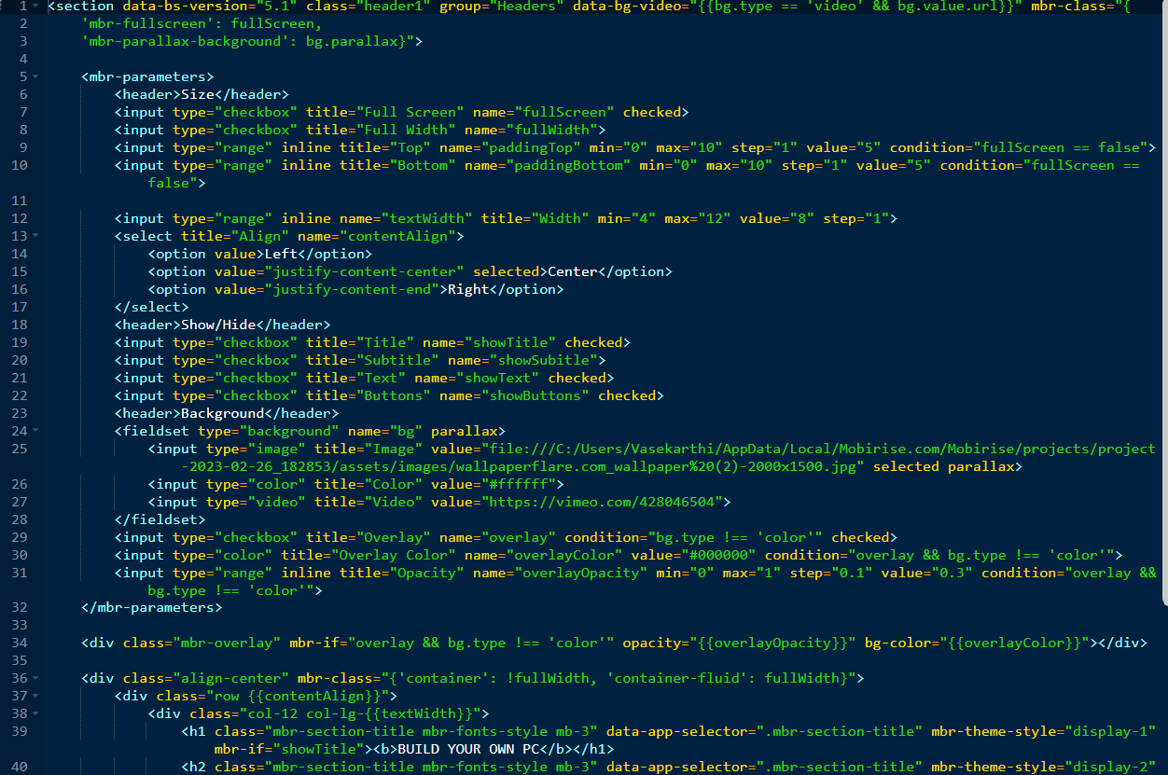

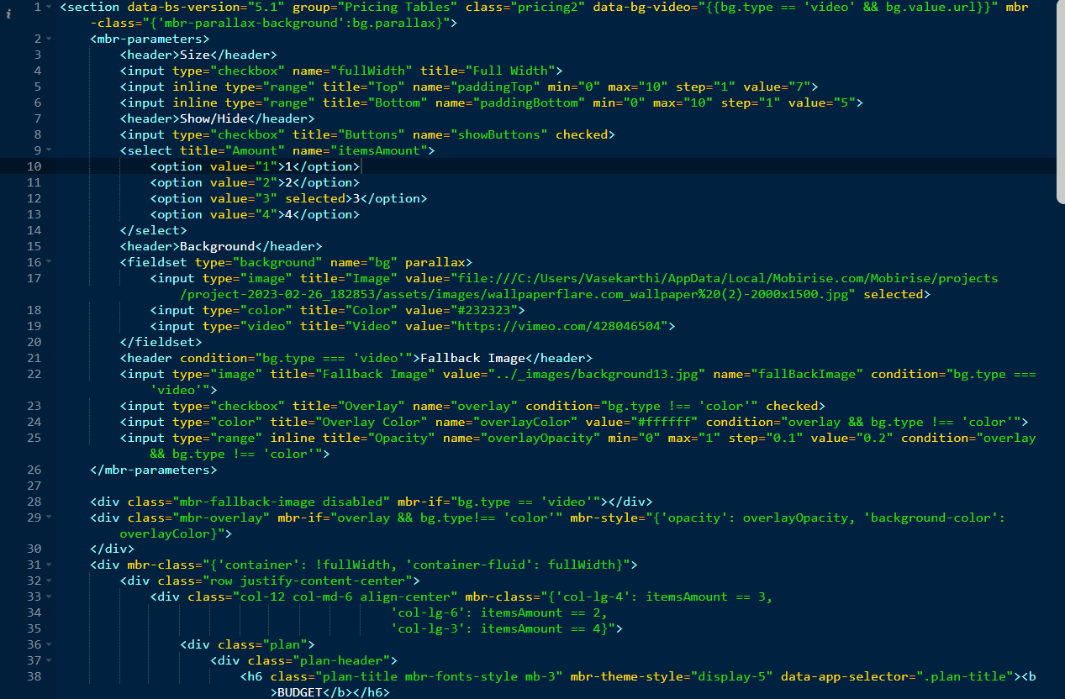

**7.3. PROJECT SPECIFIC** **TEST CASES**

**Gaming Test Cases:**

These test cases focus on evaluating the gaming performance of the suggested systems. They may include benchmarks for popular games, testing the systems' ability to run games smoothly at various graphics settings and resolutions. The test cases could cover factors like frame rates, graphical fidelity, and compatibility with different gaming accessories.

**Productivity Test Cases:**

These test cases assess the suitability of the suggested systems for general productivity tasks such as office work, web browsing, and multitasking. They may include benchmarks for running productivity applications like Microsoft Office suite or Adobe Creative Cloud, measuring factors like application launch times, document processing speed, and system responsiveness.

**Portability and Battery Life Test Cases (for laptops**):

These test cases assess the portability and battery life of the suggested laptops. They may involve measuring factors like weight, dimensions, battery runtime under different usage scenarios, and charging time.

**Connectivity and Expansion Test Cases:**

These test cases evaluate the connectivity options and expandability of the suggested systems. They may include tests for Wi-Fi performance, USB transfer speeds, availability of ports (e.g., HDMI, USB-C, Thunderbolt), and the ability to upgrade or add components in the future.

**8. SAMPLE OUTPUT**

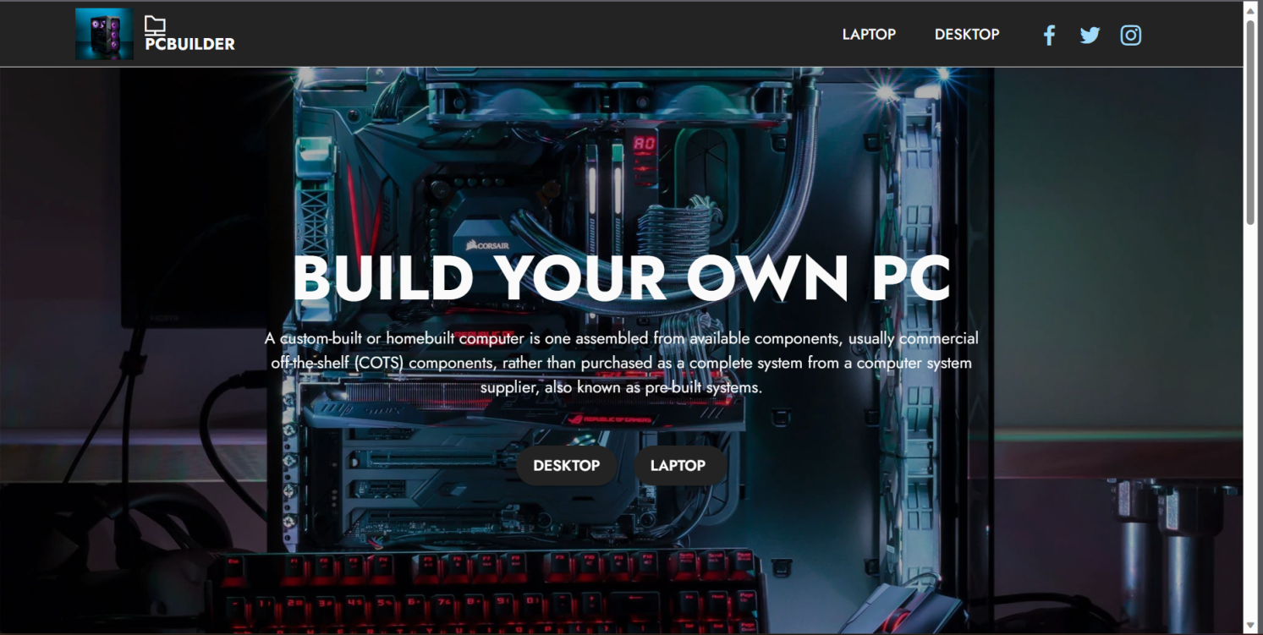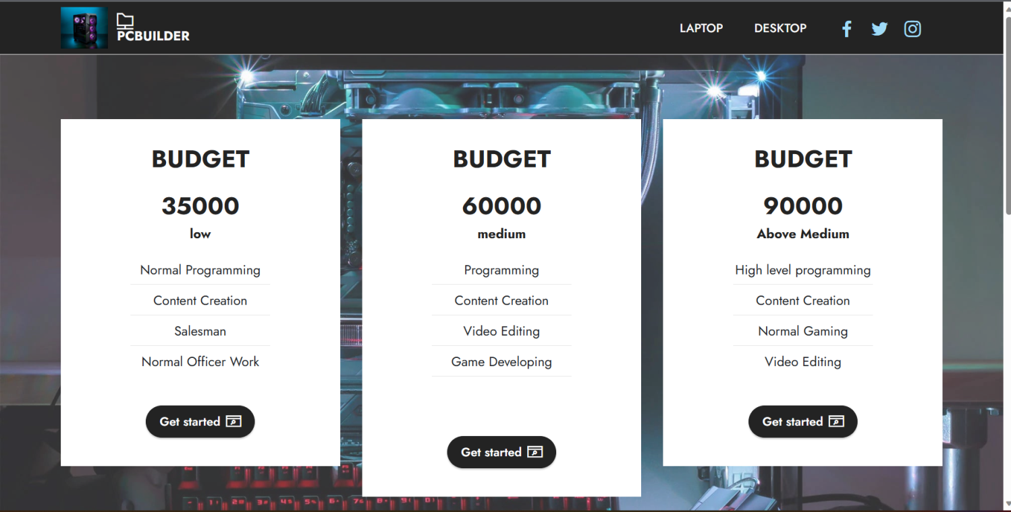

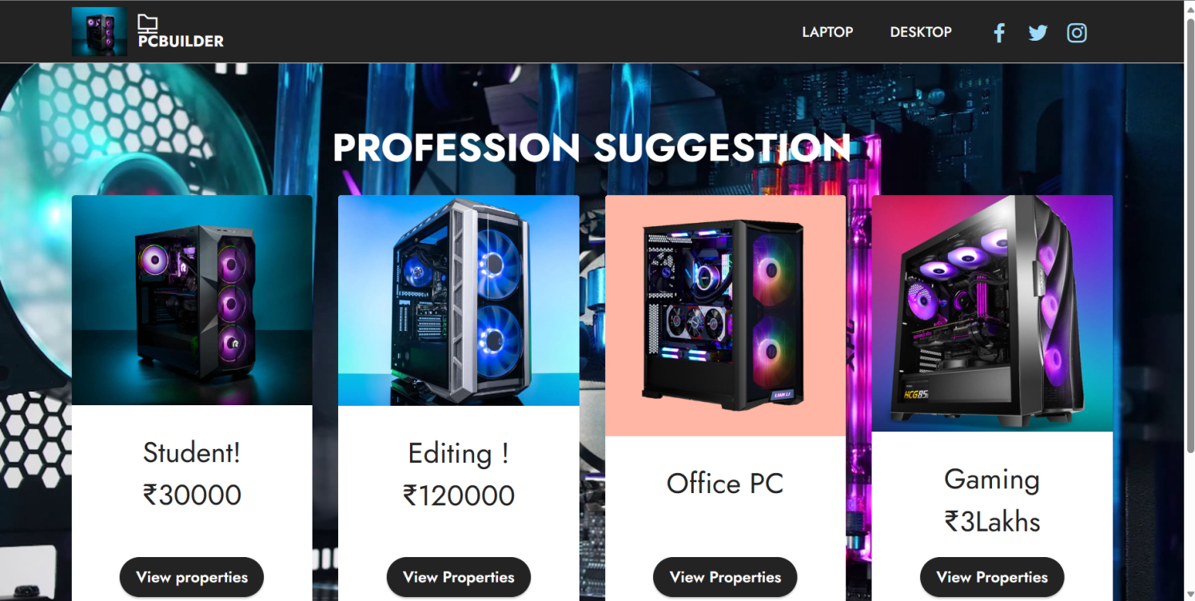

**9. BENEFITS**

Building a PC can be daunting, especially for those who are not familiar with the intricacies of hardware compatibility. Pre-PC build websites typically offer compatibility checks, ensuring that all selected components are compatible with each other. This helps users avoid common pitfalls and ensures a smooth building process.

By providing a variety of component options and price ranges, these websites can help users find the best balance between performance and cost. They often offer recommendations based on budget constraints, ensuring users get the most value for their money.These websites often provide user reviews, ratings, and benchmarks for various components, helping users make informed decisions. This allows users to benefit from the experiences of others and gain insights into the performance and reliability of different products.

Some pre-PC build websites offer information on the power consumption and efficiency of different components. This can be helpful for users who are conscious of energy consumption or looking to build an environmentally friendly system. It allows users to make choices that align with their energy-saving goals.

**10. LIMITATION**

Although pre-PC build websites may offer competitive pricing, they may not always reflect the best available deals or promotions in the market. Users should compare prices across multiple sources and check the availability of components from different retailers to ensure they are getting the best value for their money.While pre-PC build websites often perform compatibility checks, there can still be instances where certain components may not work optimally together, despite passing compatibility tests. Unforeseen conflicts or issues can arise during the actual assembly process. Users should be prepared to troubleshoot or seek additional assistance if compatibility issues arise.

The prices of computer components can fluctuate due to market conditions, availability, and demand. While pre-PC build websites may strive to offer competitive pricing, the prices listed on their websites may not always reflect the most up-to-date prices. Users should be prepared for potential price variations and do independent price comparisons to ensure they are getting the best deal.

**11. FUTURE ENHANCEMENT**

Improving the accuracy and real-time nature of component availability and pricing information can enhance the user experience. Integration with reliable data sources and partnerships with retailers can enable pre-PC build websites to provide up-to-date information on stock availability, price fluctuations, and discounts, ensuring users have the most accurate information for their purchasing decisions.

Encouraging users to contribute their own reviews, ratings, and experiences can enhance the knowledge base and community engagement of pre-PC build websites. Implementing features such as user forums, user-generated build showcases, and comprehensive user feedback systems would allow users to share their expertise, build recommendations, and troubleshooting solutions, fostering a vibrant and collaborative community.

Pre-PC build websites can develop more comprehensive benchmarking and performance analysis tools. This would allow users to compare the performance of different components or pre-built systems based on specific tasks or applications. Advanced analytics and visualization techniques can help users make informed decisions about the performance capabilities of their desired configurations.

As part of our commitment to continuously improve our services, we have exciting plans for future enhancements to our platform for selling product IDs and game invoice IDs. We are dedicated to providing an even better user experience and expanding the range of offerings available to our customers.

**12. REFERENCE**

1. PCPartPicker (<https://pcpartpicker.com/>)

2. A2d Channel (https://www.youtube.com/@A2DChannel)

3. CNET (https://www.cnet.com/): CNET is a technology news and review website that provides comprehensive reviews and buying guides for pre-built PCs and laptops.

4.Tom's Hardware (https://www.tomshardware.com/): Tom's Hardware is a well-known website offering hardware reviews, news, and buyer's guides. They cover a wide range of topics, including pre-built PCs and laptops.

5. TechRadar (https://www.techradar.com/): TechRadar provides reviews, news, and buying advice for various technology products, including pre-built PCs and laptops.